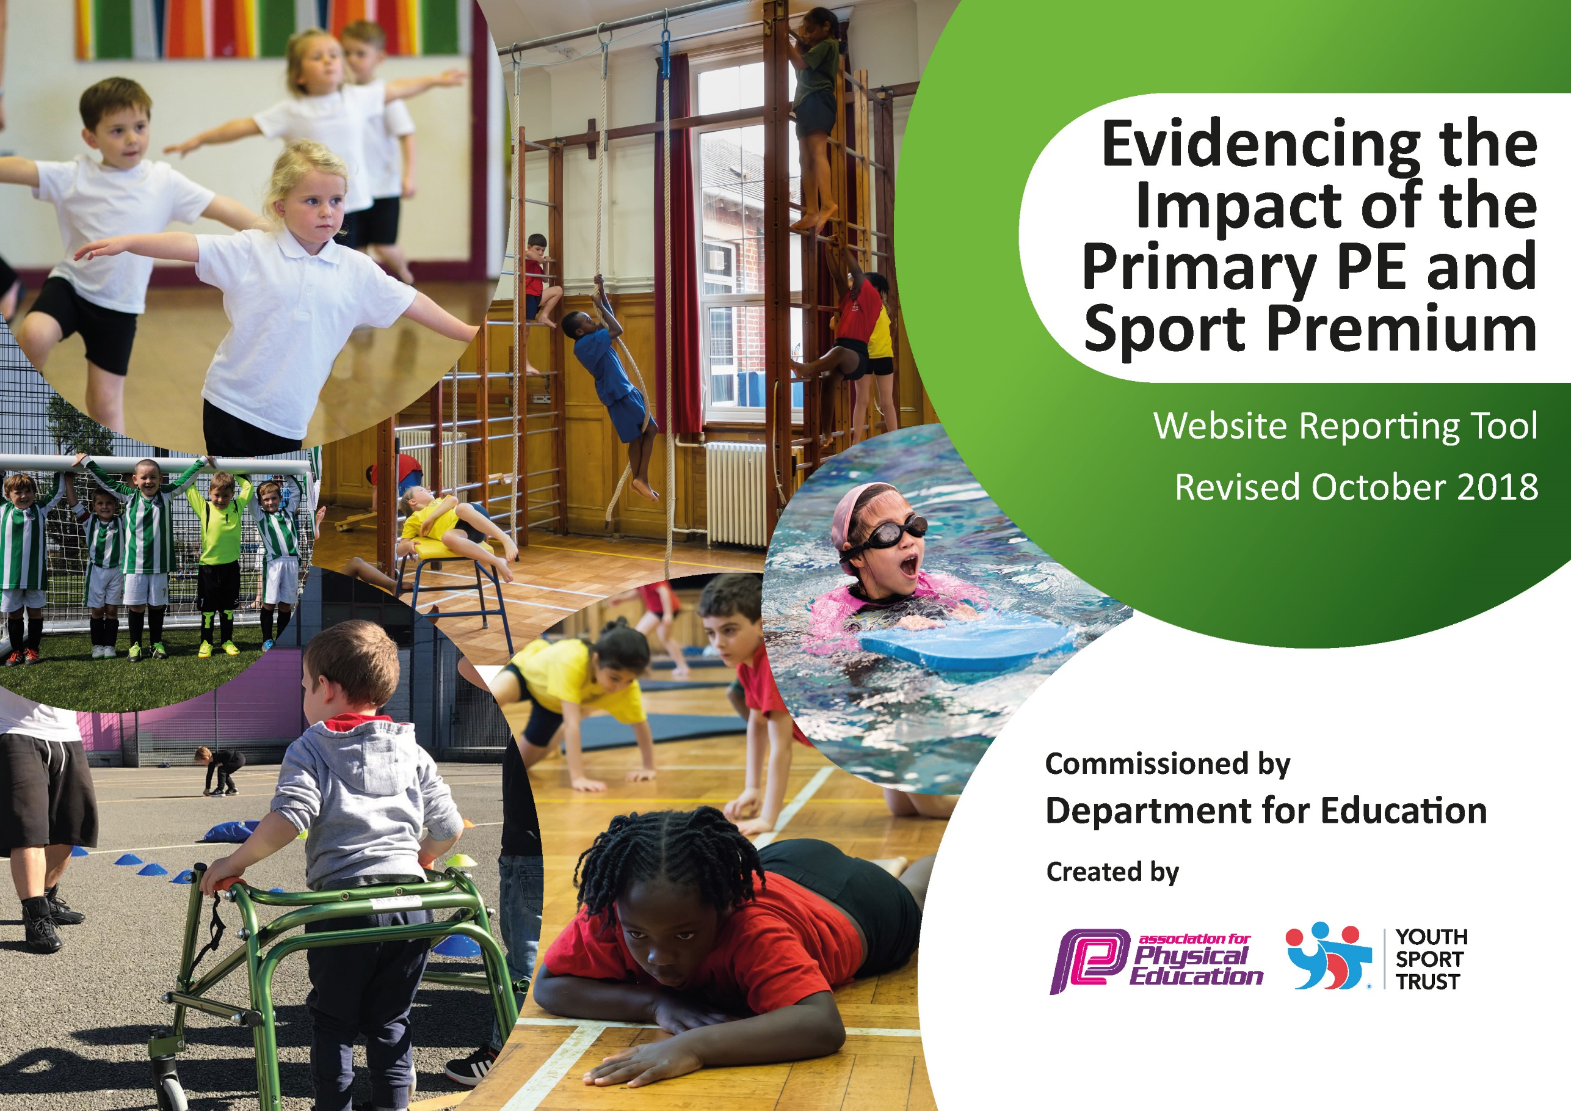
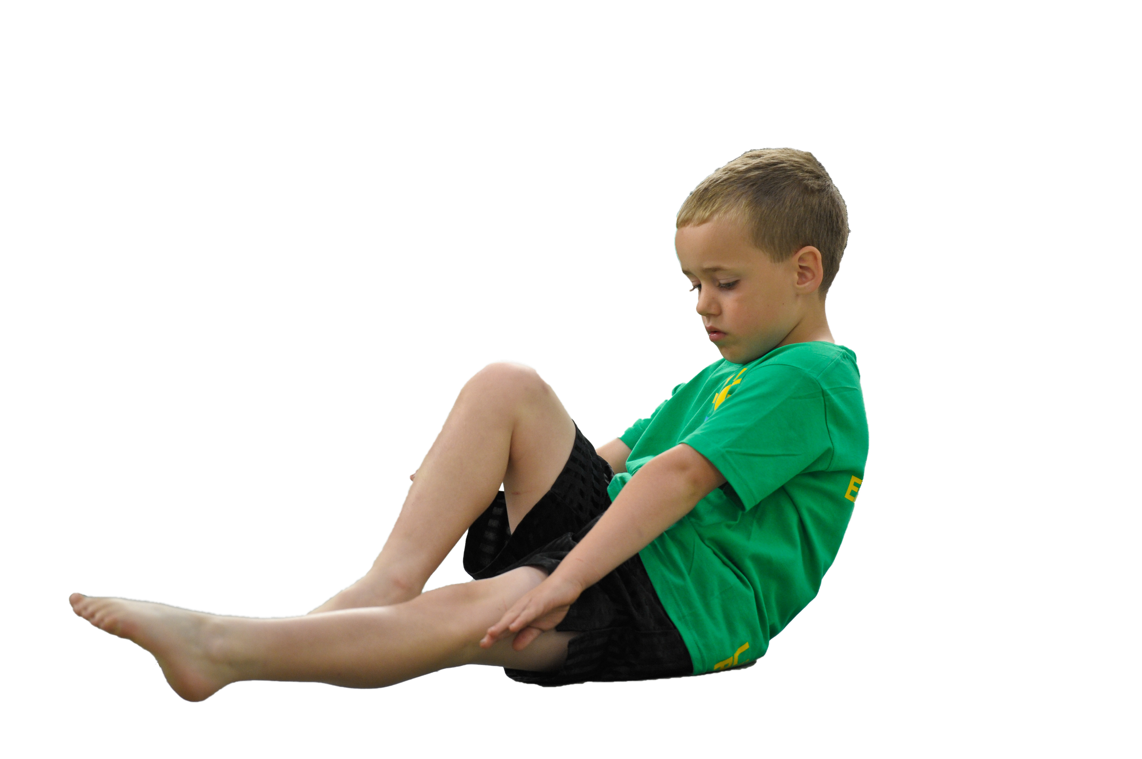
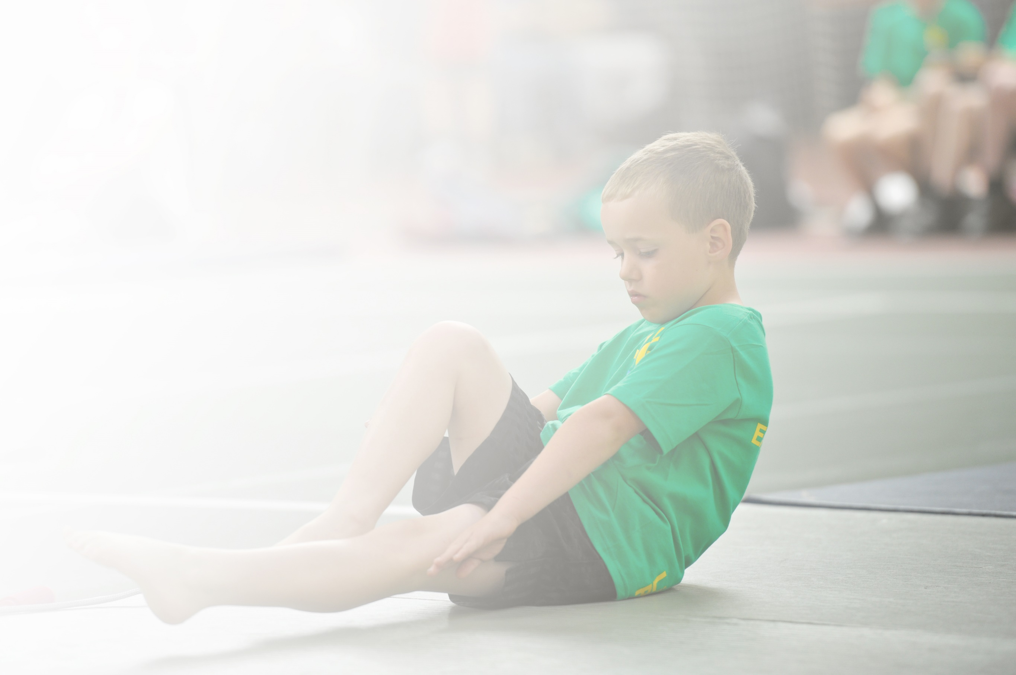
Schools must use the funding to make additional and sustainable improvements to the quality of Physical Education, Sport and Physical Activity (PESPA) they offer. This means that you should use the Primary PE and Sport Premium to:

- Develop or add to the PESPA activities that your school already offer
- Build capacity and capability within the school to ensure that improvements made now will benefit pupils joining the school in future years

Please visit gov.uk for the revised DfE guidance including the 5 key indicators across which schools should demonstrate an improvement. This document will help you to review your provision and to report
your spend. DfE encourages schools to use this template as an effective way of meeting the reporting requirements of the Primary PE and Sport Premium.

We recommend you start by reflecting on the impact of current provision and reviewing the previous
spend. Under the Ofsted Schools Inspection Framework, inspectors will assess how effectively leaders use the Primary PE and Sport Premium and measure its impact on outcomes for pupils, and how effectively governors hold them to account for this.

Schools are required to publish details of how they spend this funding as well as on the impact it has on pupils’ PE and sport participation and attainment by the end of the summer term or by 31 July 2019 at the
latest.
We recommend regularly updating the table and publishing it
on your website throughout the year, as evidence of your
ongoing review into how you are using the money to
secure maximum, sustainable impact. To see an
example of how to complete the table please
click HERE.

Support for review and reflection - considering the 5 key indicators from DfE, what development needs are a priority for your setting and your students now and why? Use the space below to reflect on previous spend, identify current need and priorities for the future.

Key achievements to date: | Areas for further improvement and baseline evidence of need:
SoccerStars are leading regular lunchtime and after school clubs, which have had a good uptake.  Yogabugs have been a great success throughout the year working with FS2 and KS1.  Sports equipment is of a good standard to allow effective PE lessons.  Festivals participated in throughout the year by all year groups.  Bikeability enables the pupils to become confident when riding a bike and learn road safety. | Assessment tools to be implemented – worked closely with Murray Park (Local Secondary school) to develop progress grids (to be implemented in 19-20).  Mentoring and coaching for staff to develop their understanding across the year.  To compete in a competitive sports on a regular basis.

Meeting national curriculum requirements for swimming and water safety | Please complete all of the below:
What percentage of your current Year 6 cohort swim competently, confidently and proficiently over a distance of at least 25 metres?  N.B. Even though your children may swim in another year please report on their attainment on leaving  primary school. | 33%
What percentage of your current Year 6 cohort use a range of strokes effectively [for example, front crawl, backstroke and breaststroke]? | 29%
What percentage of your current Year 6 cohort perform safe self-rescue in different water-based situations? | 29%
Schools can choose to use the Primary PE and Sport Premium to provide additional provision for swimming but this must be for activity over and above the national curriculum requirements. Have you used it in this way? | Yes/No

Action Plan and Budget Tracking
Capture your intended annual spend against the 5 key indicators. Clarify the success criteria and evidence of impact that you intend to measure to evaluate for students today and for the future.

Academic Year: 2018/19 | Total fund allocated: £7860 | Date Updated:24/7/19
Key indicator 1: The engagement of all pupils in regular physical activity – Chief Medical Officer guidelines recommend that primary school children undertake at least 30 minutes of physical activity a day in school |  |  |  | Percentage of total allocation:
 |  |  |  | 44%
School focus with clarity on intended impact on pupils: | Actions to achieve: | Funding allocated: | Evidence and impact: | Sustainability and suggested next steps:
To increase the level of physical education throughout the school day. | SoccerStars lead lunchtime clubs to increase purposeful physical education throughout the school day.  The daily Mile, children to partake in daily in all year groups. | £3510  (lunchtime and afterschool clubs throughout the year:  Lunchtime  £50 per week  After school club  £40 per week  N/A | All year groups have worked with the SoccerStar coaches.  Pupil voices identify that pupils have enjoyed the sessions and look forward to them.  All sessions are timetabled to ensure that all of the pupils receive coaching.  Worked well at the start of the year, some teachers have found it difficult to fit into the school day. Mix response from pupils. | To continue with Soccerstars to run lunchtime clubs.  To use SoccerStar coaching to mentor and coach members of staff to develop staffs confidence when teaching a variety of sports.  To timetable the Daily Mile on a daily basis.
Key indicator 2: The profile of PESSPA being raised across the school as a tool for whole school improvement |  |  |  | Percentage of total allocation:
 |  |  |  | 19%
School focus with clarity on intended impact on pupils: | Actions to achieve: | Funding allocated: | Evidence and impact: | Sustainability and suggested next steps:
To raise the profile and positive view of sports in the school for both pupils and staff. | Pupils attended a number of festivals as whole classes and as targeted pupils. Sen pupils and PP pupils were targeted to increase participation in sport.  Sports Day – Pupils completed a range of activities and achieved throughout the morning. | £1500  £50 | Feedback from pupils and pupil voices were very positive, particularly from children who were not regularly active.  Feedback from SLT, Parents and the PTFA identified positive feedback. Pupils also shared this. | To continue with this next year to give pupils opportunities of different sports.  To increase the number of assemblies focused on sport to raise the profile of sport amongst pupils.

Key indicator 3: Increased confidence, knowledge and skills of all staff in teaching PE and sport |  |  |  | Percentage of total allocation:
 |  |  |  | 19%
School focus with clarity on intended  impact on pupils: | Actions to achieve: | Funding  allocated: | Evidence and impact: | Sustainability and suggested  next steps:
To ensure teachers feel confident to teach PE to a good standard. | To identify areas of PE that teachers feel less confident to teach and identify strengths which can be shared across the school.  Derby SSP schemes of work were introduced last year, this year we have focused on ensuring that we have enough and staff are using them and feel confident to do so. Staff have received advice and feedback on this from the PE co-ordinator where they have required and asked for it. | N/A  $1500 | PE audit identified gaps and strengths in teachers’ confidence and skill sets; this will be used to plan future training needs.  Teachers have said they feel confident to use the scheme and feel they are now providing effective PE teaching from them. | Plan appropriate training and coaching based on the analysis from audit. Provide audit for any new members of staff next year.  Continue to ensure schemes are being used across the school. Complete learning walks to monitor if they are being used effectively across the school.
Key indicator 4: Broader experience of a range of sports and activities offered to all pupils |  |  |  | Percentage of total allocation:
 |  |  |  | 100%
School focus with clarity on intended  impact on pupils: | Actions to achieve: | Funding  allocated: | Evidence and impact: | Sustainability and suggested  next steps:
To offer children a range of sporting activities.  Additional achievements:  DSSP festivals and tournaments participated in.  Trinity Warriors Dance Group  YogaBugs  SoccerStars  Break dancing club  Move to learn – Derby County  Bikeability | Pupils have participated in a variety of festivals and competitions throughout the year. All year groups have participated in these.  Pupils participated in a break dance scheme of the whole year, which lasted 15 weeks.  FS2 and KS1 have participated in weekly Yogabug sessions.  Pupils have participated in lunchtime and afterschool clubs.  Year 6 attended a break dancing club as a reward. The scheme lasted for the Spring term.  Derby County in the community worked with both Year 5 classes during Spring 2.  The children attended Bikeability sessions with cycle Derby. | £1500  free  £2400  £3510  Free  Free  £400 | Pupils participated and stated through pupil voices their enjoyment during the festivals and competitions.  Pupils participated in a group performance. Parents and Pupils stated the positives.  Yogabugs report and feedback (see PE file)  Feedback from pupils and member of staff.  Feedback from pupils.  Feedback from the pupils and members of the staff involved with the lessons. The lessons involved practical and theory based in the classrooms.  Pupils participated in lessons over two days. The pupils worked in small groups to ensure maximum effectiveness. | To continue next year. This will mean pupils get a different experience to this year.  To continue next year.  To continue next year.  To continue next year.  To continue next year and perform in front of the school.  To continue to use Derby County scheme in the future.  Bikeability to be used next year. Continue to use the scheme with a greater number of pupils.
Key indicator 5: Increased participation in competitive sport |  |  |  | Percentage of total allocation:
 |  |  |  | 19%
School focus with clarity on intended  impact on pupils: | Actions to achieve: | Funding  allocated: | Evidence and impact: | Sustainability and suggested  next steps:
To increase pupils want to participate in sport.  Pupils attended DSSP competitions throughout the year.  Sports Day | Pupils participated in a competitive environment.  All year groups participated in a competitive environment. All pupils participated in at least 3 races in front of the school and parents | £1500  £50 | Pupils stated their enjoyment in pupil voices.  Feedback from SLT, Parents and the PTFA stated the high levels of enjoyment of the pupils. The competitive spirit was identified as the children wanted to win each race. Whilst the pupils were racing, the encouragement and cheering shown by the pupil audience was also stated. | To enter a range of DSSP competitions next year.  To continue to use a competitive sports day next year. Ensure that all of the staff are given adequate time to practise each race during PE lessons during Summer 1.

